What we need to write a gameManager code so that we can play the game again and again
We can start the game when it was tapped first time and we can also keep the score
Disable the block in the heirarchy panel
Now create two empty object that is gamemanager and spawnPoint
This point is the point where our block will keep spawning
Reset its position
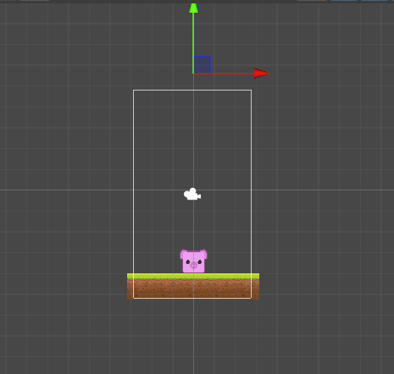
Now position the spawn point above the screen as shown above so that it can spawn block right from here.
So what we are trying to do is manipuate its x position to create a random new position and then create(spawn) block from it and our player will dodge the block from anywhere
Now connect the game manager asset in the heirarchy to the gamemanager
Now open our gameManger Script
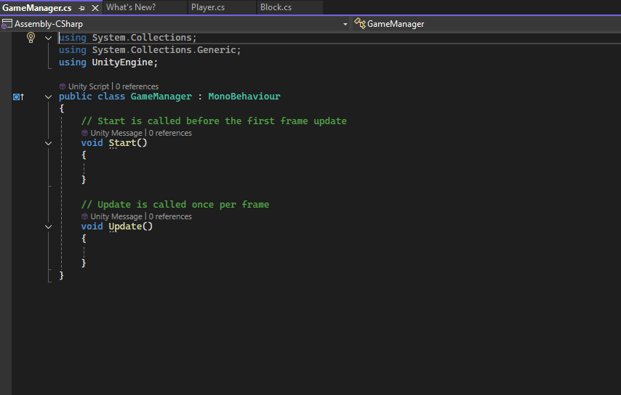
we will create a variable block of type GameObject this will keep the reference of our block IOA that we can spawn the block and instantiate the block.
We declare another public variable maxX this variable will decide the limit upto which we can spawn the block(Maybe the values given are scalesensitive who knows)
We will create another variable spawnPoint of type Transform So this will hold the reference of the spawnPoint so that we can actually understand at which at which we need to spawn the game object
then we will declare another variable spawnPoint So this spawnRate will decide how fast we want to spawn the blocks
Lets suppose we spawn one block and then after one second spawn the second block
Now we will create another variable of gameStarted of type boolean so this will decide if our game has started or not by default it will be false
We don't need start method
So now our code will look like below
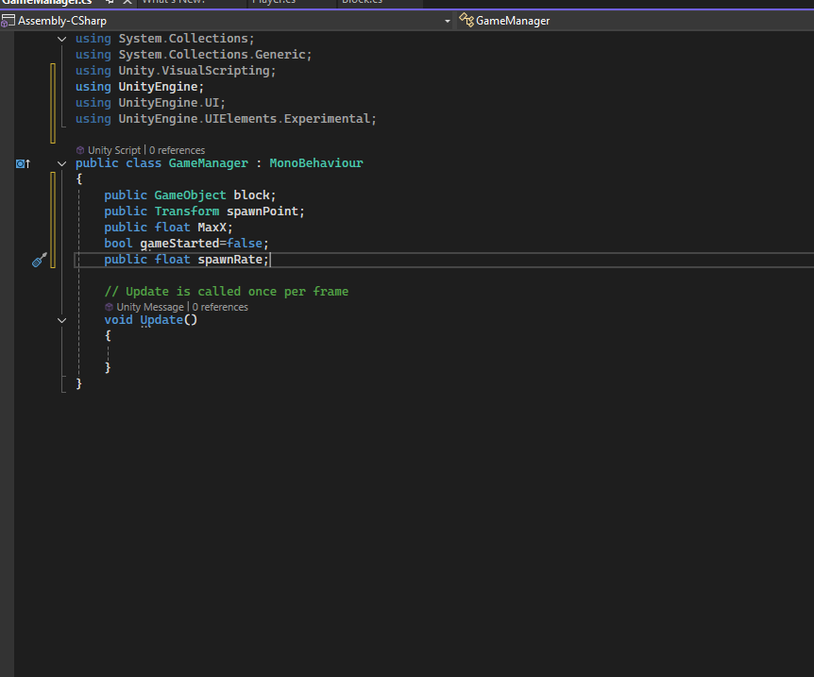
Now we will create another method inside our class named spawnBlock which will be used to spawn the block
First we need a position where we can spawn the block
Now inside it we create another variable spawnPos and initialise it with spawnPoint .position
Now we get the spawnPoint position Now we will create random position along x axis so that we can spawn at random position
Now we will give random position to x position of spawnPoint with the help of Range method inside Range class It will give random number between specified range
we set the range -maxX and maxX which we will set in our unity game engine.
So now we are creating random x position for spawnpoint
and then we need to instantiate our block at this random position
So now the code will look like below
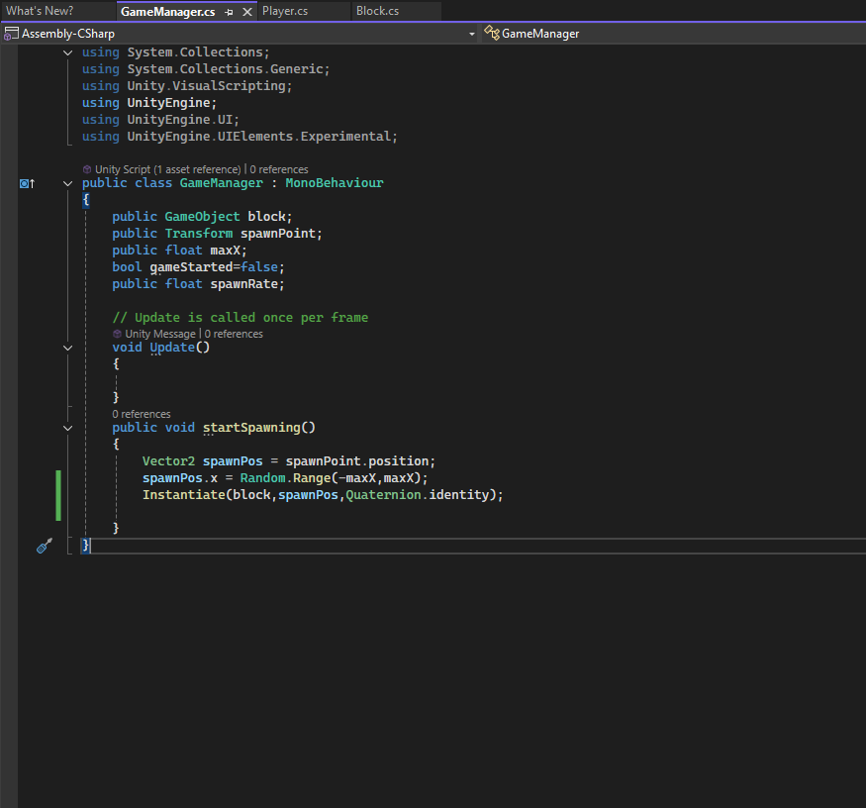
Sure!
In Unity, `Quaternion.identity` means "no rotation at all." Think of it like a reset button for an object's rotation.
When you use it, the object will be facing straight ahead, just like it starts when you first create it.
So, if you want an object to go back to its original position without any twists or turns, you would use `Quaternion.identity`.
In simple terms, this line of code places a new block at a specific spot in the game without turning it in any direction.
Now we need to repeatedly call this spawnBlock method
For that we need to call other method we will call it Startspawning
Inside it we call Invokerepeating function
This function will call the name of the function passed as an argument into it after a particular interval
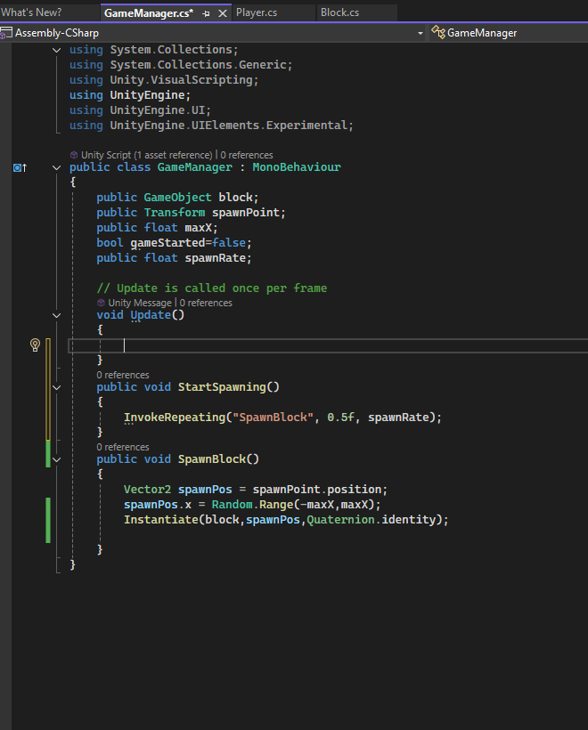
So in InvokeRepeating you pass the name of the function you want to call again and again
In second argument we tell that after what duration we will call the function specified in the first argument and in third argument we tell that after what time the function will be called again and again
So our block will be spawned one by one repeatedly at random position and after certain interval leaving the time after which the initial block was created(It will be mentioned in second argument), if the StartSpawning method will be called.
We add spawnRate as third argument
So what we need to do is call the start spawning function whenever the game starts
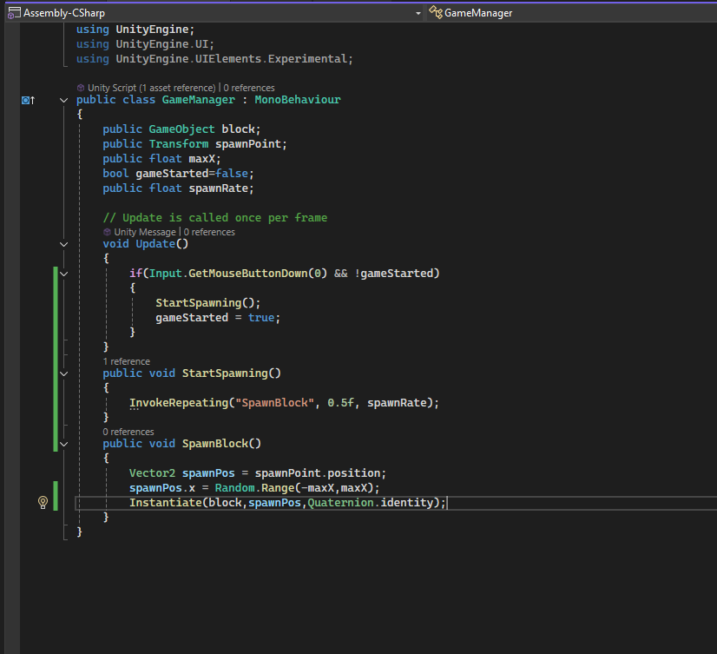
____________________________________________________________________________

In Unity, Input.GetMouseButton(0) and Input.GetMouseButtonDown(0) are used to detect mouse input, but they work a bit differently:
- Input.GetMouseButton(0):
  - This checks if the left mouse button (button 0) is currently being held down.
  - It returns true every frame that the button is held down, so you can use it for continuous actions, like dragging.
- Input.GetMouseButtonDown(0):
  - This checks if the left mouse button was pressed down in the current frame.
  - It returns true only for the frame when the button is initially pressed, making it useful for actions that should happen just once per click, like firing a shot or starting an action.

Summary:
- Use GetMouseButton for actions while holding the button down.
- Use GetMouseButtonDown for actions when the button is first pressed.

So basically what we are trying to do is checking whenever there is a touch on the screen is the game started or not if not then the startspawning will be called and the gameStarted varaible will be set to true and when the game started and then touch happens then nothing will happen
So now we will go to Unity add the references and see how this is working
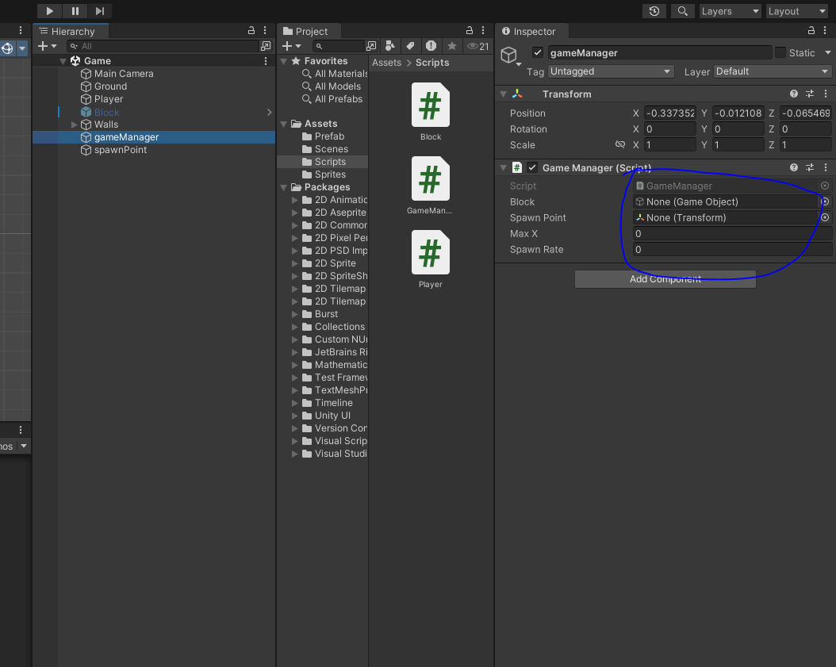
Now inside the inspector panel of gameManager we have some references to add in our script as marked which will be used inside our script as they were public
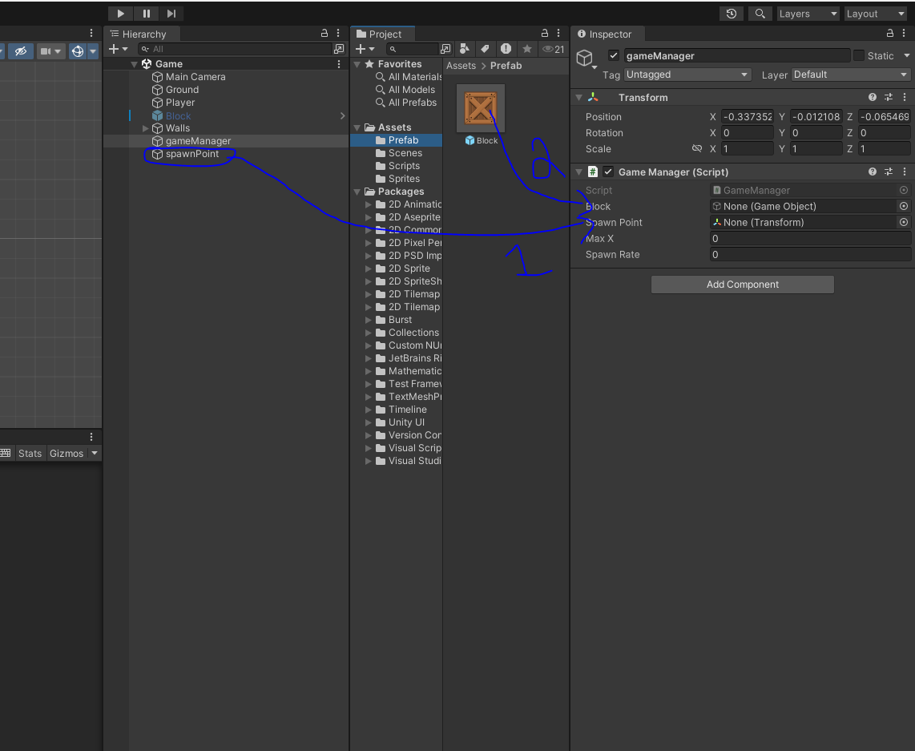
we will drag and drop the spawn point IOA to the Spawn point field in Script panel as marked 1 above
and then we will add block from Prefab folder as marked above then it will create the block from it and since the block will be destroyed when it reach the bottom so thats why we take it from prefab
New findings:-
Prefab is like a permanent store from where you can clone anything but if your object is present in the scene then you don't even need it but if it is not present in the scren then you can use it from prefab.
And i think that the empty object does not take origin center of the screen s its origin unlike other IOA
Next we need to maxX position which will be the maximum upto which you can spawn the block
So we will take the extreme x position value of the left that the block touches the left edge of the screen since it takes origin as center so the extreme value of right should be its positive counterpart
Now take this value and set it to maxX.
So when you run the Unity by clicking on the marked area below
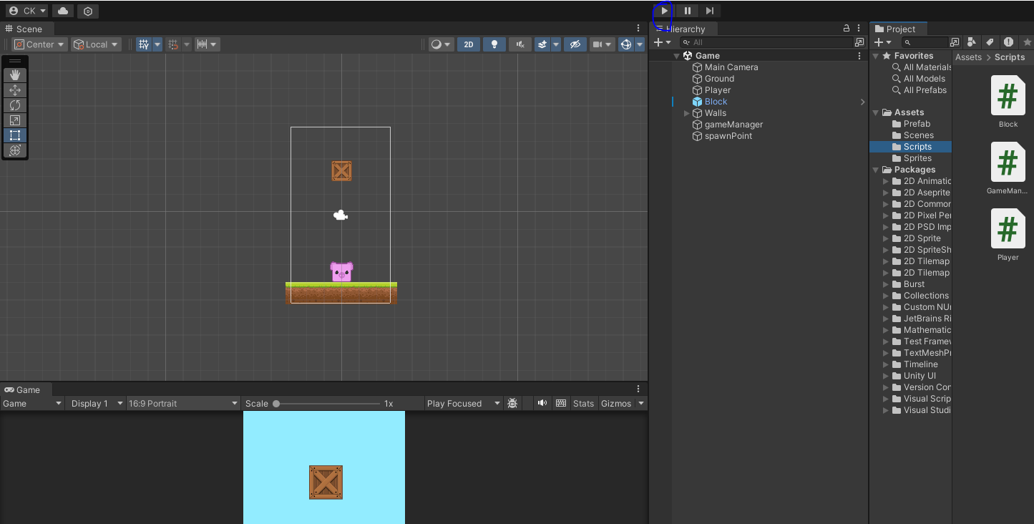
When you play it then you will see that when you tap on the screen for the first time. Then the block
start appearing from the tap from random position and then when they touch the player then the game get restarted. The random boxes will only appear when you tap on the screen for the first time .

